Game Design Document

Fill up the following document

1. Write the title of your project.

**Run win done .**

1. What is the goal of the game?

**To collect all the coins and fruits and reach the end .**

1. Write a brief story of your game.

**There are two players the bunny , teddy fighting for fruits and**

**they decided to keep a race and to collect the coins and fruits**

**and reach the ending point and win the game . the one who**

**reachs the end point will de rewarded with basket of fruits .**

1. Which are the playing characters of this game?

* Playing characters are the ones who respond to the user based on the input from the user.
* Cars, monkeys, dinos, wizards, etc., are the playing characters in the game.

|  |  |  |
| --- | --- | --- |
| Number | Character Name | What can this character do? |
| 1 | Bunny | Run , jump |
| 2 | Teddy | Run , jump |
| 3 | ----- | ----- |
| 4 | ----- | ----- |
| 5 | ----- | ----- |
| 6 | ----- | ----- |
| 7 | ----- | ----- |
| 8 | ----- | ----- |

1. Which are the Non-Playing Characters of this game?

* Non-Playing characters are the ones that don't have an action or behavior when the user interacts with the game.
* Hurdles, stones, bananas, coins, etc., are non-playing characters in the game.

|  |  |  |
| --- | --- | --- |
| Number | Character Name | What can this character do? |
| 1 | ----- | ----- |
| 2 | ----- | ----- |
| 3 | ----- | ----- |
| 4 | ----- | ----- |
| 5 | ----- | ----- |
| 6 | ----- | ----- |
| 7 | ----- | ----- |
| 8 | ----- | ----- |

Draw your imagination of this game. What does this game look like?

* Draw the game either on your computer or on paper.
* Add images of the game scenes to show each of the playing and non-playing characters at least once.

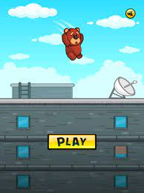

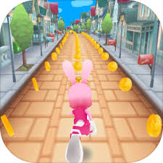

How do you plan to make your game engaging?

**By adding animations , background , sounds .**